|  |
| --- |
| Professional Development Plan  2018 |
|  |
|  |



2023 - Present

Ella Greene

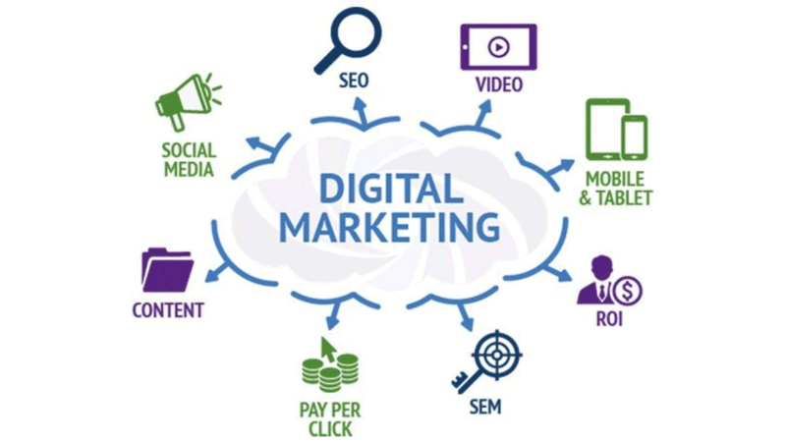

Cate Hollowitsch, Instructor

Marketing Career Preparation Course

Western Technical College

Dear Cate,

Paragraph 1: Imagine yourself in 3 years

In three years, I imagine myself pursuing one of my dream careers. In hopes, that I possibly work for a travel company or a recreational company, in regard to running their social media accounts. I would love to work in this industry because I think it’s a great opportunity for me to explore my interests and to learn more about digital marketing.

Paragraph 2: Highlight 1 specific goal, habit, skill, or self-reflection that will help you be your best future self. What did you connect with this semester?

One habit, such as journaling, has allowed me to become more present about the things around me. This allowed me to connect to my inner self and learn about my strengths and weaknesses. Not only does journaling help me become more present, but it allows me to express my emotions in a more calm and orderly manner.

Paragraph 3: Highlight 1 specific goal, habit, skill, or self-reflection that will help you be your best future self. What did you connect with this semester?

A skill, such as learning about digital marketing has helped me shape my skills to become more professional. I want to become skilled when learning about this topic, because it’s my program and it’s going to prepare me for my future career. I would love to manage a social media account for a recreational company, and I think digital marketing would greatly help me.

Paragraph 4: Offer a brief outline of sections below, and a short conclusion

All of these habits, skills, and self-reflections help me connect with my future self and how I’m going to learn about myself. I believe that in three years, I will be pursing my goals with patience and trust within my decisions from now on. These assignments throughout these classes has helped me learn about a wide range of topics and how to strengthen my skills.

Sincerely,

Ella Greene

Self-Assessments

Type Focus/ Truity

In this assessment I learned about my personality type, which is ISFP. ISFP stands for introverted, sensing, feeling, and perceiving. This type of personality is known to be tolerant and nonjudgmental, and loyal to those around them. This assessment allowed me to learn about how I perceive others around me, and how they can view me in a working environment.

Worldview

In this assessment, I found out that I’m an integrative worldview. This assessment explained the difference of four worldviews and how each person sees the universe differently. This means that I see the universe as evolving, driven in values in self-actualization, believe in global peace, and have a strong compassion. Learning about this worldview, has allowed me to learn more about my identity and what characters connects me mentally and physically.

Daily Habits

Daily Email Checks: Checked at the start of my day.

Results Paragraph – Since incorporating daily email check-ins, I find that I am…

Journaling: Expressed at the end of my day.

Since I’ve been journaling each night, I’ve noticed that I’ve became more present and aware of my environment. Journaling has helped my express my feelings and write down things that are not easy for me to talk about me. It gives me to a chance to communicate and allow my emotions to flow more freely without focusing all my attention on my disturbances in life.

Exercise: A form of cardio or strength exercise every day.

Participating in daily exercise has allowed me to stay more active and healthier. The exercise can be very low maintenance, but it’s good as long as I’m getting some type of exercise in my daily life. I’ve noticed that by exercising every day, it’s helped me stay focused and determined to get a good balance while allowing myself to practice healthy boundaries.

Planning a Daily Schedule: Set reminders throughout the day.

I’ve noticed that when I plan my schedule for the next day, I become more organized and focused on my workload. This also helps keep a good balance in doing my work and allowing me to redirect my focus on things that need to get brought attention to.

Goals

SMART Goal 1: I want to improve my active performance.

Details – By improving my active performance, it allows me to learn more about my abilities and how I can establish healthy boundaries for myself. After a tough day, I usually resort to physical activity to relieve my stress levels. By improving my active performance, I can stay motivated in doing my schoolwork and getting in some exercise throughout my life.

SMART Goal 2: I want to become an ambassador for an outdoors brand.

Details – By becoming an ambassador, I can learn more of what it means to represent a brand. I’ve always been interested in doing this, because I love clothes that represent a traveling cause within their brand. I think reaching out to a company, would be a good way to start and to learn more of what it means to be an ambassador.

Strategies for Growth

Skills Gap Analysis (Students will list below items identified in the SGA and action steps to narrow the gap)

Skill – Mastery of Excel

Description: Briefly explain this skill.

Action Step: Take an online course for Excel at (insert source here)

Date of Completion: June 2022

Skill – Learn Skills in Digital Marketing

Description: This skill will help me gain more knowledge about my program and how I’m going to gain information throughout my courses. It will contribute to learning about advertising, promotions, and social media.

Action Step: Take courses related to Digital Marketing

Date of Completion: May 2025

Skill – Learn about Social Media

Description: Learning about social media will heavily contribute to digital marketing. Social media is a heavy influence on the world that is constantly revolving around us so it’s important to gather information when new trends are brought to attention.

Action Step: Take courses related to Digital Marketing and Social Media

Date of Completion: May 2025

Skill – Reach out to Brands

Description: By reaching out to brands, I will gain more information about social media, digital marketing, and public relations. By having this skill, it will allow me to become more present and communicative when exploring my future career.

Action Step: Message a brand and reach out

Date of Completion: May 2024

Timeline

Academic Plan

Below is my academic plan for graduating with a degree in Digital Marketing.

Fall 2022

* Marketing Career Preparation
* Marketing Principles
* Promotion Principles
* Software Applications for Business

Spring 2023

* Content and Copy Writing
* Internet Marketing
* Digital Design Components
* Digital Advertising
* English Composition

Summer 2023

* Marketing-Research
* Project Management
* Math w Business Apps

Fall 2023

* E-Commerce
* Social Media Strategies
* SEO and Marketing Analytics
* Speech

Spring 2024

* Consumer Behavior
* Integrated Marketing Campaign
* Personal Brand Management
* Economics

Summer 2024

No listed courses for this term.

Annotated Bibliography

<https://www.westerntc.edu/node/7274/academic-programs/digital-marketing/courses>

Western Technical College

The academic programs from the Western Technical College website shows me the list of classes that I will be taking throughout my semesters. It helps inform me to stay on task and register for the classes I need to take within specific requirements.

<https://docs.google.com/document/d/1NzixEvntRNcXqetsbG4IQynGv9haDBMS/edit?usp=drive_link&ouid=101624815080785751604&rtpof=true&sd=true>

Ella Greene

Throughout Marketing Career Preparation, I learned about self-assessments that showed my strengths and weaknesses. Many of these self-assessments included factors like stress, financial assistance, motivation, worldview, and much more. These assessments showed me how important it is to learn from your mistakes and grow by making better choices for yourself.

<https://docs.google.com/presentation/d/17ZvEc98s0oa3H5b0LwzygtAQIdI3714M/edit?usp=sharing&ouid=101624815080785751604&rtpof=true&sd=true>

Ella Greene

In this google presentation, I wrote up several features that includes information about me and my work. In this, I also gained a bigger perspective on my skills and my goals throughout life. It helped me learn about how I was going to manage my skills by showcasing them throughout future projects to learn more about myself.